Discrepancies in Protective Orders Highlights Difficulty of Domestic Violence Resource Accessibility in Western Mass

Mattea Whitlow

2025-02-16

## Domestic Violence in Massachusetts Remains a Serious Issue

Last year, 19 people were murdered by an intimate partner in Massachusetts alone. [According to Jane Doe Inc.](https://www.janedoe.org/there-were-19-domestic-violence-homicides-in-massachusetts-in-2023-data-show/), a coalition against intimate partner violence (IPV) and sexual assault in the state, Massachusetts saw an average of 18 domestic violence homicides a year within the last decade. Additionally, over ⅓ of Massachusetts women report some form of IPV in their lifetime.

Despite being one of the lowest percentages in the country, this number is horrifyingly high.

Domestic violence cases span the entire state, but the rates at which people seek and receive protective orders – a key step to preventing intimate partner homicides and a potential signifier of the prevelance of IPV – are actually not so evenly distributed.

### Discrepancies in Case Filings in Western MA

Looking at [the official data](https://www.mass.gov/doc/restraining-orders-209a-and-harassment-orders-258e-case-filings) of restraining and harassment order case filings from 2012-2023 released by the Massachusetts Court System, disparities in the rates of protective orders are glaringly obvious at the county level, particularly when focusing on Western Massachusetts.

Combining the restraining and harassment order data with [county level population](https://dlsgateway.dor.state.ma.us/reports/rdPage.aspx?rdReport=Socioeconomic.Population.population_main) data for the same time period, crude rates of case filings for protective orders can be calculated.

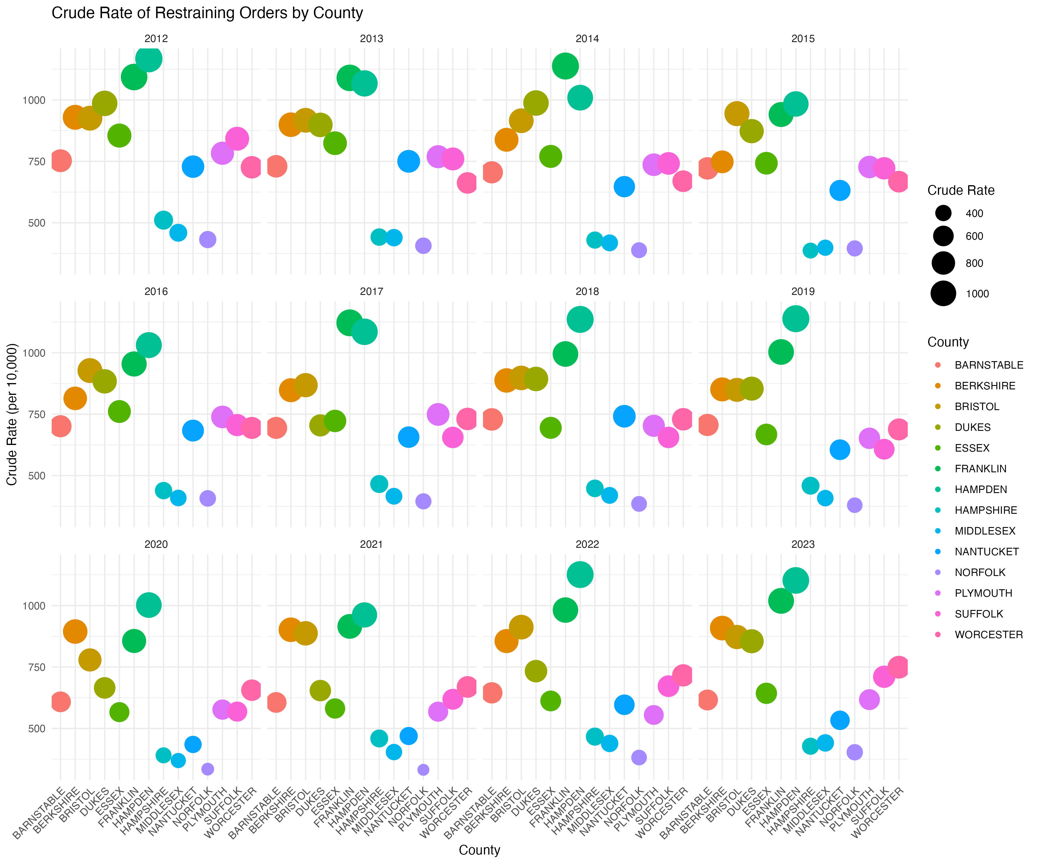

The crude rate of protective order filing in Franklin county (and Hampden county) was about **2:1** compared to Hampshire county every year between 2012 and 2023. A few years saw filing rates over 2.5 times greater in Franklin than in Hampshire. This means that, despite having a population which is under half of Hampshire’s, people in Franklin county were seeking protective orders at **at least twice the rate** of Hampshire residents.

While the actual numbers of cases filed *are* low, and the relative proportion of the population filing these orders is also small, the fact that such a large difference exists between these two neighboring counties should make us wonder why this inequality in protective order filings exists.

### Why is Franklin County’s Protective Order Filing Rate so High?

One potential reason for the discrepancy in these rates lies in the rural nature of Franklin county and the resulting barriers to accessing domestic violence resources. Franklin county is the most rural county in Massachusetts in terms of [population density](https://www.census.gov/quickfacts/fact/table/franklincountymassachusetts/PST045224). [Previous studies](https://pmc.ncbi.nlm.nih.gov/articles/PMC3216064/) have shown that women living in isolated areas report experiencing IPV at higher rates than women in urban areas, and often struggle to access resources meant to support them.

[MassGov lists](https://www.mass.gov/info-details/list-of-domestic-violence-services-by-massachusetts-county) 2 official resources for victims of IPV in Franklin county, one of which is in Northampton and the other in Greenfield. About three quarters of Franklin’s residents live outside of Greenfield. Given the rurality of the county itself, accessing these two sources, one of which is an up to 30 minute car ride or a longer bus commute from the other, could pose a serious challenge for those trying to get help or seeking support outside of the court system. People without cars, and those who need extra discretion are particularly vulnerable.

Hampshire county’s reported 5 official resources are spread more evenly throughout the denser county, which could allow residents to access non-legal assistance such as safe housing. As a result, victims of IPV in Franklin county who are unable to access official or effective support may rely on court ordered protections more often, leading to higher filing rates.

Official data about granting protective orders or results of domestic violence cases are not available online, making it difficult to determine the efficacy of community and local responses to domestic violence in the counties. However, it is clear that people facing IPV in certain parts of Western Massachusetts are interacting quite differently with the legal system when compared to their neighbors. Given the impact that physical isolation has on both experiencing domestic violence and receiving help to escape these dangerous situations, a serious effort needs to be made to ensure that all people can access these crucial resources, no matter how small or rural the area is.